Part 1:

From the canvases created, the core requirements for the downtime calculation tool are:

1. **Functional Requirements**
   * Downtime Calculation Algorithm: Automate accurate compensation calculations for Uber and Lyft drivers.
   * Integration with Insurance Systems: Connect with internal insurance APIs for claim data.
   * Compliance Features: Built-in checks to meet insurance standards and regulatory requirements.
   * Web Portal for Adjusters: Provide a secure, user-friendly interface for insurance adjusters.
   * Real-Time Reporting: Display calculation results instantly for faster claim approvals.
   * Audit Trail: Track all actions for compliance and auditing purposes.
2. **Non-Functional Requirements**
   * Security: Ensure secure cloud infrastructure and data protection.
   * Performance: Fast processing to reduce claim delays.
   * Scalability: Support multiple insurance systems and adjusters.
   * Usability: Intuitive UI for adjuster workflows.
3. **Additional Features**
   * Training & Onboarding Module: Help adjusters learn the tool.
   * Support System: Direct assistance for adjusters.

Part 2&3: This is the basic wireframe for the loss. This is done with Figma.

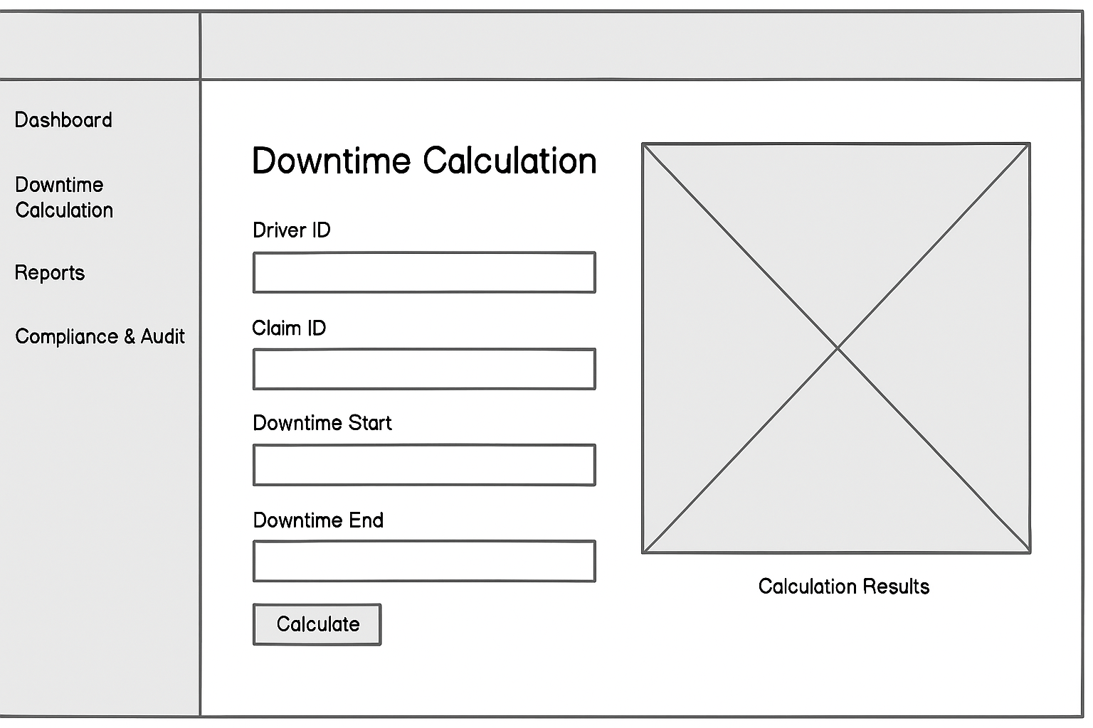

Part 4 Feedback

**Wireframe Review Feedback Form**

**Reviewer Name:** Tony Mudrak  
**Date:** 1/4/2025

**1. Overall Design**

* Is the layout clear and easy to understand?  
  X Yes ☐ No  
  Comments: It is clear but there could be some gussying up on the layout.

**2. Navigation**

* Are the menu options (Dashboard, Downtime Calculation, Reports, Compliance & Audit) intuitive?  
  X Yes ☐ No  
  Comments: Need to be more updated in the layout and the background.

**3. Functionality**

* Do the input fields (Driver ID, Claim ID, Downtime Start, Downtime End) make sense for the task?  
  X Yes ☐ No  
  Comments: Yes this makes sense but there also needs to be what company they drive for.

**4. Usability**

* Is the “Calculate” button placed logically and easy to find?  
  X Yes ☐ No  
  Comments: NONE

**5. Results Display**

* Is the placeholder for calculation results clear and appropriately positioned?  
  X Yes ☐ No  
  Comments: It is good for a tablet not for a cell phone.

**6. Suggestions for Improvement**

* What changes would you recommend improving the wireframe?  
  Comments: More updated background and more functionality with the menus.

Step 5:

